The Shars of Gharchistan: Guardians of Eastern Iranian Identity and the Avestan Homeland
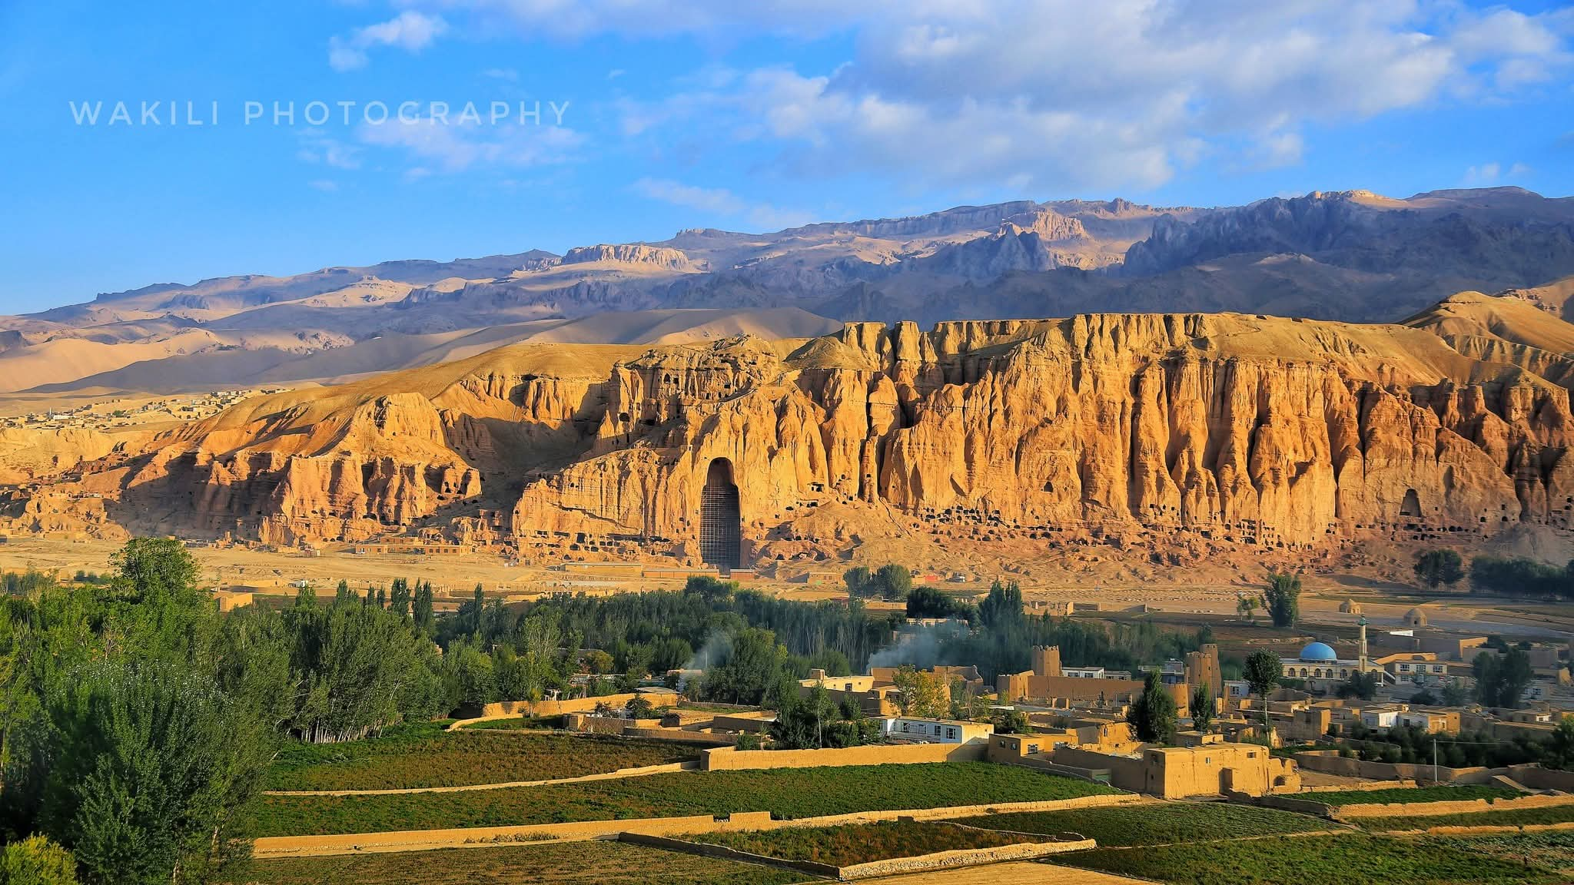
Abstract

This paper examines the Shars (Shārān) of Gharchistan, an indigenous Iranian princely dynasty that ruled the mountainous highlands of central Afghanistan—the heart of the Avestan Airyanem Vaejah—from the pre-Sasanian period until their subjugation by the Ghaznavid Empire in the early 11th century CE. Drawing on the Encyclopaedia Iranica and the Great Islamic Encyclopaedia, this study establishes that the title Shār derives from the Old Persian xšaθra ("kingship, sovereignty"), demonstrating the dynasty's deep roots in pre-Islamic Iranian civilization. The paper documents the Shars' fierce resistance to Mahmud of Ghazni, culminating in the famous defiant poem of the Shar ruler Barāzanda: "I am neither Turk, nor Arab, nor Afghan, nor demon—I bear the mark of Sām, Gudarz, and Gīv; I am the son of Garshāsp, of Aryan lineage." The study further establishes that the Shar capital, Abeshīn (modern Shāristān in Daykundi Province), lay at the very core of the Avestan sacred geography, and that the Shars maintained their independence from Sasanian rule, never paying tribute to the Persian emperors of the west. Finally, the paper contextualizes the modern political appropriation of the name "Iran" by Reza Shah Pahlavi in 1935, contrasting it with the ancient Aryan identity that the Shars embodied in the eastern highlands.

---

1. Introduction: The Shars and the Eastern Iranian World

The Shars (Shārān) of Gharchistan represent one of the last surviving indigenous Iranian dynasties of the eastern Iranian plateau, ruling the central highlands of what is today Afghanistan—a region that corresponds to the Avestan Airyanem Vaejah (the "expanse of the Aryans"). The title Shār itself—meaning "greatness and lordship"—derives from the Old Persian xšaθra (kingdom, sovereignty), confirming the dynasty's unbroken connection to the pre-Islamic Iranian imperial tradition.

The kingdom of Gharchistan (also known as Gharchāl-Shār, "the mountainous land of the Shars") comprised the highlands between Herat and Kabul, encompassing the upper reaches of the Murghab River. Its capital was Abeshīn (also recorded as Bashīn, Nishīn, Afshīn, Pishīn)—a city whose name likely derives from the Persian pishīna ("ancient"). Today, this site corresponds to the district of Shāristān in Daykundi Province, the very heart of the Hazarajat (Āzrah-jat).

---

2. The Title "Shār": Etymology and Indigenous Iranian Origin

The Great Islamic Encyclopaedia (Dā'irat al-Ma'ārif-i Buzurg-i Islāmī) provides decisive evidence for the Iranian origin of the title Shār:

"Shār was the title of the rulers of Gharchistan, meaning 'king,' derived from xšaθra in the Old Persian language."

The same source further establishes that Gharchāl-Shār meant "the mountainous region of the Shars" or "the king's mountain". In other regions, local rulers were called Shīr (lion), which Marquart notes is the New Persian translation of the same ancient title. The poet Nāṣir-i Khusraw (11th century) explicitly distinguishes the rulers of Bamiyan as Shīr and the rulers of Abeshīn as Shār—both deriving from the same Old Persian root.

Critically, the Great Islamic Encyclopaedia confirms that the Arabic names later attached to the Shars (such as "Abū Naṣr Muḥammad" and "Shāh Muḥammad") were imposed by later Muslim historians and do not reflect the indigenous titulature of the dynasty. The dynasty's own title—Shār—remained purely Iranian.

---

3. The Shars' Independence from the Sasanian Empire

The Great Islamic Encyclopaedia provides remarkable evidence of the Shars' independence from Sasanian rule:

"Gharchistan in the Sasanian period (224–652 CE) apparently did not pay tribute to Iran... even from the time of King Fīrūz I (457–484 CE), the territories east of Marv al-Rūd, including Gharchistan, were outside the control of the Iranian state."

This establishes that the Shars were never vassals of the Sasanian emperors—unlike many other regions of the Iranian plateau. They maintained their sovereignty throughout the Sasanian period, preserving an independent eastern Iranian identity that traced its lineage not to the western Persian court but to the ancient heroic traditions of the Avestan world.

---

4. The Shars and the Avestan Homeland of Airyanem Vaejah

The territory of the Shars—the highlands of central Afghanistan—corresponds precisely to the Avestan Airyanem Vaejah, the "homeland of the Aryans" described in the Vendidad (Fargard 1) as the first of Ahura Mazda's sixteen perfect lands. The Shars thus ruled the very cradle of Zoroastrian civilization, the sacred geography that gave birth to the Avestan language and the epic traditions of the Iranian world.

The Great Islamic Encyclopaedia notes that Gharchistan's location extended from Herat in the west to Ghuristan in the east, from Marv al-Rūd in the north to Ghaznin in the south—a territory encompassing the entire central highlands where the Avestan tradition flourished.

---

5. The Shars' Defiance of Mahmud of Ghazni

5.1 Historical Background
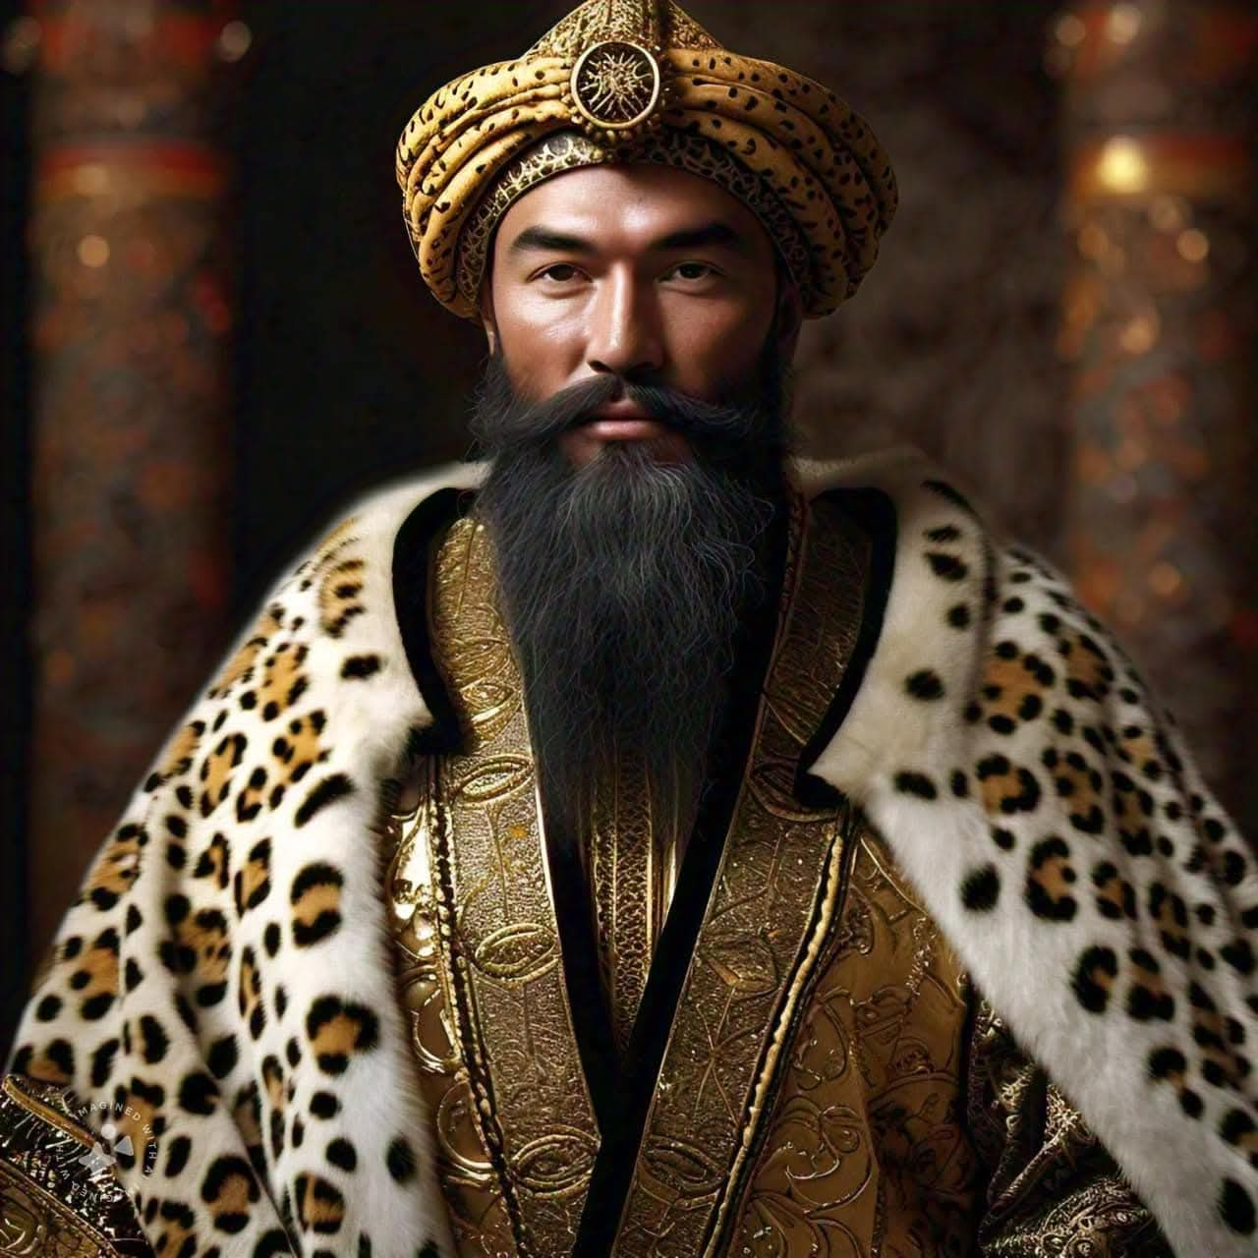

The Shars initially maintained vassal relations with the Samanids of Bukhara. In 999 CE, following the Samanid collapse, Sultan Mahmud of Ghazni—a Turkic ruler from the Ghaznavid dynasty—demanded that the Shars read the khutba (Friday sermon) in his name. The Shars consented and maintained loyal relations until approximately 1011–1012 CE.

The rupture occurred when the younger Shar refused to accompany Mahmud on one of his Indian expeditions. Mahmud used this refusal as a pretext for invasion. The elder Shar submitted without resistance, but the younger Shar (Shāh Muḥammad) chose to fight.

5.2 The Poem of Barāzanda

The younger Shar's resistance is immortalized in a defiant poem attributed to the Shar ruler Barāzanda (or Barāzandeh), recorded in the lost Manzūma-i Zābulistān ("Poetic History of Zabulistan"). The poem reads:

"Neither Turk am I, nor Arab, nor Afghan, nor demon—
I bear the mark of Sām, Gudarz, and Gīv.
I am the son of Garshāsp, of Aryan lineage—
I am the legacy of the wise Hūshang."

And further:

"You are but a Turk, a slave born of Dādū—
How dare you claim lordship over me?
Not Zabul, not Kabul, is your rightful place—
If you were born of Dādū, to Dādū you shall return!"

This poem is a remarkable document of pre-Islamic Iranian identity surviving into the 11th century. The Shar explicitly distances himself from the Turkic Ghaznavids, the Arab conquerors, and even the Afghan tribes, asserting instead his lineage from the legendary heroes of the Shāhnāma: Sām, Gudarz, Gīv, Garshāsp (Kərəsāspa in the Avesta), and Hūshang—figures rooted in the eastern Iranian epic tradition of Zabulistan and Sistan.

5.3 Outcome

Mahmud's army besieged the younger Shar in a mountain fortress. Both Shars were sent to Ghazna; Gharchistan was annexed to the Ghaznavid Empire. The younger Shar was kept in close custody until his death, while the elder Shar——was treated with respect and given a position of honour at Mahmud's court. He died in 1015 or 1016 CE.

---

6. The Shars' Capital: Abeshīn / Shāristān

The Great Islamic Encyclopaedia identifies Abeshīn as "one of the two great cities and the ancient capital of the province of Gharchistan". Located on the upper course of the Murghab River, the city's name appears in various forms: Bashīn, Nishīn, Bishīn, Afshīn, Pishīn, and Abeshīn.

The linguist Justi suggests the original form was Pishīna ("ancient"), which later evolved into Pishīn, Fashīn, Abeshīn, and Afshīn. Today, this ancient capital corresponds to the district of Shāristān in Daykundi Province—a name that preserves the title of the Shars.

---

7. The Modern Appropriation of "Iran": 1935 and its Implications

In 1935, Reza Shah Pahlavi of Iran officially requested that the international community refer to the country as "Iran" rather than "Persia". The name "Iran" derives from the Avestan Airyanem ("of the Aryans")—the very same sacred geography that the Shars ruled for centuries.

The historical irony is profound:

· The Shars of Gharchistan, ruling from their capital at Abeshīn (modern Shāristān in Daykundi), were the direct heirs of Airyanem Vaejah—the Aryan homeland itself.
· They preserved this identity for over a millennium, maintaining their independence from both the Sasanian Empire and the Arab caliphates.
· In 1935, the name "Iran" was politically claimed by the western Persian state centered in Tehran—a state that had never controlled the eastern highlands of Gharchistan, and whose ancestors, the Sasanians, had failed to subjugate the Shars.

The Shars' defiant poem—"I am neither Turk, nor Arab, nor Afghan, nor demon; I am the son of Garshāsp, of Aryan lineage"—stands as the earliest explicit assertion of an "Aryan" identity in the eastern Iranian world, predating the modern political appropriation of the name by nearly a millennium.

---

8. Chronological Summary

Date Event
Pre-224 CE Shars ruling Gharchistan; independent of Sasanian control
224–652 CE Sasanian period; Gharchistan remains outside Sasanian control
976–997 CE Abū Naṣr Muḥammad (elder Shar) rules; patron of scholars
994 CE Simjurid invasion; Shars temporarily flee
999 CE Samanids fall; Shars accept Mahmud's suzerainty
1012 CE Mahmud invades Gharchistan; younger Shar resists
1015–1016 CE Elder Shar dies in Ghazna
12th century Shars mentioned as serving the Ghurids
1935 Reza Shah Pahlavi officially adopts the name "Iran"

---

9. Conclusion

The Shars of Gharchistan represent one of the most significant yet least studied indigenous Iranian dynasties of the eastern highlands. Drawing on the Great Islamic Encyclopaedia and other authoritative sources, this paper has established:

1. The title Shār derives from Old Persian xšaθra, confirming the dynasty's pre-Islamic Iranian origins.
2. The Shars were never vassals of the Sasanian Empire, maintaining their independence throughout the Sasanian period.
3. Their territory corresponds to the Avestan Airyanem Vaejah, the original Aryan homeland described in the Vendidad.
4. The Shar capital, Abeshīn, is modern Shāristān in Daykundi Province, at the heart of the Hazarajat.
5. The Shars fiercely resisted Mahmud of Ghazni, producing a defiant poem in which the Shar ruler explicitly asserts his Aryan identity and rejects Turkic, Arab, and Afghan designations.
6. The Arabic names attached to the Shars (Abū Naṣr Muḥammad, Shāh Muḥammad) were imposed by later Muslim historians and do not reflect the dynasty's indigenous titulature.
7. The modern political appropriation of the name "Iran" in 1935 by Reza Shah Pahlavi postdates the Shars' own Aryan identity by nearly a millennium.

The Shars of Gharchistan were not merely a local dynasty; they were the guardians of the Avestan homeland, the preservers of pre-Islamic Iranian identity in the eastern highlands, and the last independent rulers of a region that gave birth to the Zoroastrian tradition itself. Their history—and their defiant poem—deserves a central place in the narrative of Iranian civilization.

---

References

1. Great Islamic Encyclopaedia (Dā'irat al-Ma'ārif-i Buzurg-i Islāmī), Vol. 5, p. 558 — entry on "Abeshīn"
2. Brill Reference Works — entry on "S̲h̲ār"
3. Wikipedia — "Abu Nasr Muhammad"
4. Wikipedia — "Airyanem Vaejah"
5. DBpedia — "Abu Nasr Muhammad ibn Asad"
6. Encyclopaedia Iranica — various entries
7. Marquart, J. — Ērānšahr (cited in Great Islamic Encyclopaedia)
8. Justi, F. — Iranisches Namenbuch (cited in Great Islamic Encyclopaedia)

